# Final Project – Report

***Objective***

My main objective is to revise some Data Structures concepts from the class. Unfortunately, it only covers the LinkedList and Queue Data Structure, which means that Hash and Tree weren’t been included. However, I achieved the goal of revising some Data Structures in class and combining them with the File operation as well.

***Design***

There are 7 Main Menu Options in my project, the sixth one will create a submenu

===================

Welcome to Music Playlist

===================

======================Main Menu======================

* 1. View all current songs in the default playlist
* 2. Add song to the default playlist
* 3. Add song from playlist to queue
* 4. Remove current playing song in your queue
* 5. Create new playlist
* 6. Modify your playlist
* 7. Exit
* Your choice: 6

==================

Playlist modifying

==================

* 1. Add song to playlist
* 2. Delete your playlist
* 3. Print the playlist upon your choice
* 4. Go back to the main menu

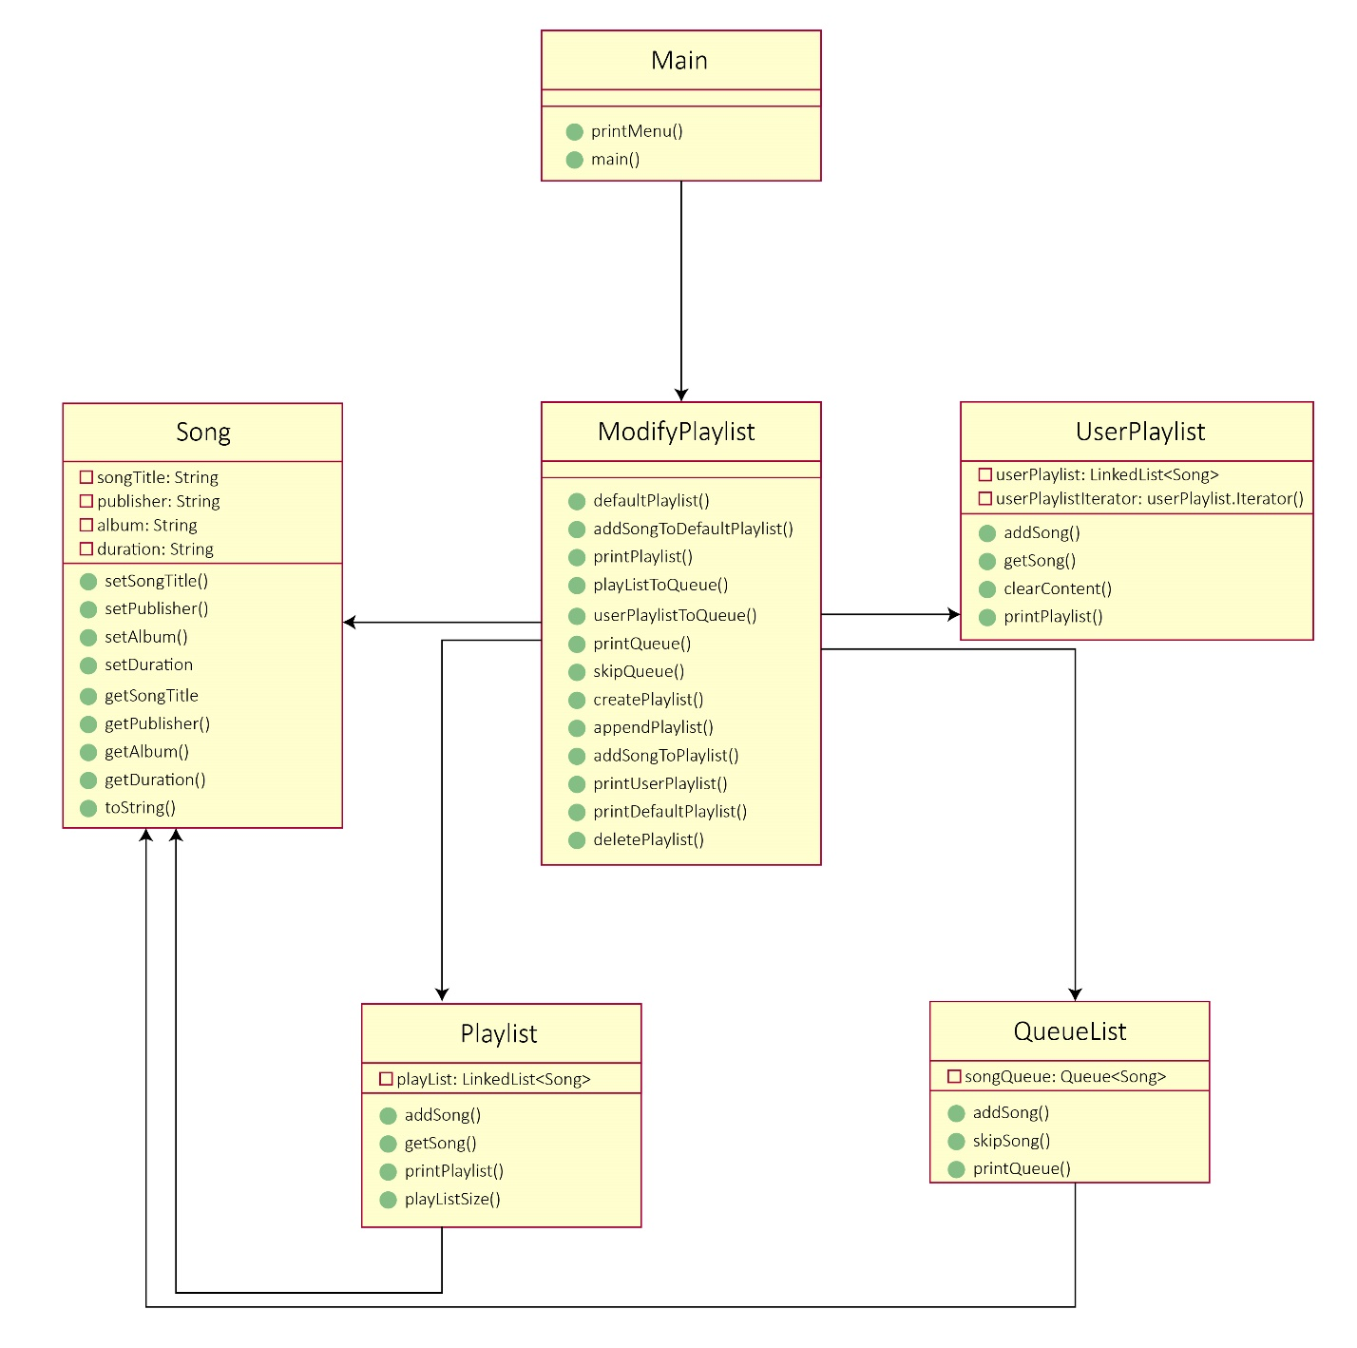

***Output***

The output is almost the same with my expectation, I checked all the conditions to make sure that there will be no error will be terminated during execution. Just one thing that I was not able to handle is the data removal concept. It took me a whole day implementing the methods but I ended up with nothing, because it requires to remove the record in the text file at the same time the record is removed in the execution. I read and watched some algorithms on the websites, understand it as well, but the best result I got is a tempFile with all the data from the playlist file. I will revise the BufferedReader, PrintWriter, etc. concepts in the future to handle it, but currently, the output I will attach below is what I can reach so far.

For the output, I created a Song.txt file storing 28 different random songs I chose from my Spotify playlists as a default playlist for my project, 2 user’s playlists I initially created from testing.

My expected output overall will be no error, the 2nd menu option will change the Song.txt file data, 5th menu option will create another .txt file if it was not existed, otherwise nothing happen, 6th menu option will move user to a submenu.

For the submenu, there will be no error as well, 1st menu option will modify a .txt file data, 3rd option will delete a .txt file if it exists, otherwise nothing happens.

The below is one sample run, however, to see how the text files are modified, refer to my description here while execution to see it.

**Sample Run:**

=========================

Welcome to Music Playlist

=========================

======================Main Menu======================

1. View all current songs in the default playlist

2. Add song to the default playlist

3. Add song from playlist to queue

4. Remove current playing song in your queue

5. Create new playlist

6. Modify your playlist

7. Exit

Your choice: 1

Track 1.

Just Give Me a Reason (feat. Nate Ruess) | The Truth About Love 4:02

Pink, Nate Ruess

Track 2.

Royals | Pure Heroine 3:10

Lorde

Track 3.

Whistle | Wild Ones 3:44

Flo Rida

Track 4.

The Fighter (feat. Ryan Tedder) | The Papercut Chronicles II 3:48

Gym Class Heroes

Track 5.

Little Talks | My Head Is An Animal 4:26

Of Monsters and Men

Track 6.

BBIBBI | BBIBBI 3:14

IU

Track 7.

Memories | Memories 3:31

Maroon 5

Track 8.

Any Song | Any song 3:47

ZICO

Track 9.

Rude | Don't Kill the Magic 3:44

MAGIC!

Track 10.

Blame (feat. John Newman) | Motion 3:32

Calvin Harris, John Newman

Track 11.

Somebody That I Used to Know | Making Mirrors 4:04

Gotye, Kimbra

Track 12.

Take on Me | Hunting High and Low 3:45

a-ha

Track 13.

How You Like That | THE ALBUM 3:00

BLACKPINK

Track 14.

Payphone | Overexposed 3:51

Maroon 5

Track 15.

How can I love the heartbreak, you're the one I love | SAILING 4:50

AKMU

Track 16.

I Knew You Were Trouble. | Red 3:39

Taylor Swift

Track 17.

Rolling in the Deep | 21 3:48

Adele

Track 18.

Set Fire to the Rain | 21 4:01

Adele

Track 19.

Someone Like You | 21 4:45

Adele

Track 20.

Blinding Lights | After Hours 3:20

The Weeknd

Track 21.

Who's Got You Singing Again | Who's Got You Singing Again 4:24

PREP

Track 22.

Psycho | 'The ReVe Festival' Finale 3:30

Red Velvet

Track 23.

Lovesick Girls | THE ALBUM 3:12

BLACKPINK

Track 24.

Gashinadul | The Barberettes Volume. 1 4:26

The Barberettes

Track 25.

LOVE IS OVER | 24C 3:37

LeeHi

Track 26.

REALLY REALLY | FATE NUMBER FOR 3:23

WINNER

Track 27.

Giving up | Forever Turned Around 3:10

Whitney

Track 28.

Ophelia | Cleopatra 2:40

The Lumineers

======================Main Menu======================

1. View all current songs in the default playlist

2. Add song to the default playlist

3. Add song from playlist to queue

4. Remove current playing song in your queue

5. Create new playlist

6. Modify your playlist

7. Exit

Your choice: 2

Enter your new song to the playlist in the format "Song name - Publisher/Singer - Album - Duration": Random String

Please try again

Enter your new song to the playlist in the format "Song name - Publisher/Singer - Album - Duration": Black Swan - BTS - BE - 219

Please enter the correct duration format!!

Enter your new song to the playlist in the format "Song name - Publisher/Singer - Album - Duration": Black Swan - BTS - BE - 3:18

Your current playlist

Track 1.

Just Give Me a Reason (feat. Nate Ruess) | The Truth About Love 4:02

Pink, Nate Ruess

Track 2.

Royals | Pure Heroine 3:10

Lorde

Track 3.

Whistle | Wild Ones 3:44

Flo Rida

Track 4.

The Fighter (feat. Ryan Tedder) | The Papercut Chronicles II 3:48

Gym Class Heroes

Track 5.

Little Talks | My Head Is An Animal 4:26

Of Monsters and Men

Track 6.

BBIBBI | BBIBBI 3:14

IU

Track 7.

Memories | Memories 3:31

Maroon 5

Track 8.

Any Song | Any song 3:47

ZICO

Track 9.

Rude | Don't Kill the Magic 3:44

MAGIC!

Track 10.

Blame (feat. John Newman) | Motion 3:32

Calvin Harris, John Newman

Track 11.

Somebody That I Used to Know | Making Mirrors 4:04

Gotye, Kimbra

Track 12.

Take on Me | Hunting High and Low 3:45

a-ha

Track 13.

How You Like That | THE ALBUM 3:00

BLACKPINK

Track 14.

Payphone | Overexposed 3:51

Maroon 5

Track 15.

How can I love the heartbreak, you're the one I love | SAILING 4:50

AKMU

Track 16.

I Knew You Were Trouble. | Red 3:39

Taylor Swift

Track 17.

Rolling in the Deep | 21 3:48

Adele

Track 18.

Set Fire to the Rain | 21 4:01

Adele

Track 19.

Someone Like You | 21 4:45

Adele

Track 20.

Blinding Lights | After Hours 3:20

The Weeknd

Track 21.

Who's Got You Singing Again | Who's Got You Singing Again 4:24

PREP

Track 22.

Psycho | 'The ReVe Festival' Finale 3:30

Red Velvet

Track 23.

Lovesick Girls | THE ALBUM 3:12

BLACKPINK

Track 24.

Gashinadul | The Barberettes Volume. 1 4:26

The Barberettes

Track 25.

LOVE IS OVER | 24C 3:37

LeeHi

Track 26.

REALLY REALLY | FATE NUMBER FOR 3:23

WINNER

Track 27.

Giving up | Forever Turned Around 3:10

Whitney

Track 28.

Ophelia | Cleopatra 2:40

The Lumineers

Track 29.

Black Swan | BE 3:18

BTS

======================Main Menu======================

1. View all current songs in the default playlist

2. Add song to the default playlist

3. Add song from playlist to queue

4. Remove current playing song in your queue

5. Create new playlist

6. Modify your playlist

7. Exit

Your choice: 3

You want to open which playlist: 123

The playlist doesn't exist

======================Main Menu======================

1. View all current songs in the default playlist

2. Add song to the default playlist

3. Add song from playlist to queue

4. Remove current playing song in your queue

5. Create new playlist

6. Modify your playlist

7. Exit

Your choice: 3

You want to open which playlist: Kpop

Enter track's number to add song to queue: 2

Your current Queue

------------------

Track 1.

Psycho | 'The ReVe Festival' Finale 3:30

Red Velvet

======================Main Menu======================

1. View all current songs in the default playlist

2. Add song to the default playlist

3. Add song from playlist to queue

4. Remove current playing song in your queue

5. Create new playlist

6. Modify your playlist

7. Exit

Your choice: 4

There's currently no playing song

======================Main Menu======================

1. View all current songs in the default playlist

2. Add song to the default playlist

3. Add song from playlist to queue

4. Remove current playing song in your queue

5. Create new playlist

6. Modify your playlist

7. Exit

Your choice: 3

You want to open which playlist: Song

Enter track's number to add song to queue: 22

Your current Queue

------------------

Track 1.

Psycho | 'The ReVe Festival' Finale 3:30

Red Velvet

======================Main Menu======================

1. View all current songs in the default playlist

2. Add song to the default playlist

3. Add song from playlist to queue

4. Remove current playing song in your queue

5. Create new playlist

6. Modify your playlist

7. Exit

Your choice: 3

You want to open which playlist: Song

Enter track's number to add song to queue: 17

Your current Queue

------------------

Track 1.

Psycho | 'The ReVe Festival' Finale 3:30

Red Velvet

Track 2.

Rolling in the Deep | 21 3:48

Adele

======================Main Menu======================

1. View all current songs in the default playlist

2. Add song to the default playlist

3. Add song from playlist to queue

4. Remove current playing song in your queue

5. Create new playlist

6. Modify your playlist

7. Exit

Your choice: 4

Your current Queue

------------------

Track 1.

Rolling in the Deep | 21 3:48

Adele

======================Main Menu======================

1. View all current songs in the default playlist

2. Add song to the default playlist

3. Add song from playlist to queue

4. Remove current playing song in your queue

5. Create new playlist

6. Modify your playlist

7. Exit

Your choice: 5

Enter the name of your new playlist: US-UK

You can't create duplicate playlist!!!

======================Main Menu======================

1. View all current songs in the default playlist

2. Add song to the default playlist

3. Add song from playlist to queue

4. Remove current playing song in your queue

5. Create new playlist

6. Modify your playlist

7. Exit

Your choice: 5

Enter the name of your new playlist: 123

You created the 123 playlist

======================Main Menu======================

1. View all current songs in the default playlist

2. Add song to the default playlist

3. Add song from playlist to queue

4. Remove current playing song in your queue

5. Create new playlist

6. Modify your playlist

7. Exit

Your choice: 6

==================

Playlist modifying

==================

1. Add song to playlist

2. View the playlist upon your choice

3. Delete a playlist

4. Go back to the main menu

Your choice: 1

Go to playlist: 123

Enter track's number to add song from default playlist to your playlist: 26

The song "REALLY REALLY" is added to 123 playlist

======================Main Menu======================

1. View all current songs in the default playlist

2. Add song to the default playlist

3. Add song from playlist to queue

4. Remove current playing song in your queue

5. Create new playlist

6. Modify your playlist

7. Exit

Your choice: 6

==================

Playlist modifying

==================

1. Add song to playlist

2. View the playlist upon your choice

3. Delete a playlist

4. Go back to the main menu

Your choice: 2

The playlist you want to view: 123

Track 1.

REALLY REALLY | FATE NUMBER FOR 3:23

WINNER

======================Main Menu======================

1. View all current songs in the default playlist

2. Add song to the default playlist

3. Add song from playlist to queue

4. Remove current playing song in your queue

5. Create new playlist

6. Modify your playlist

7. Exit

Your choice: 6

==================

Playlist modifying

==================

1. Add song to playlist

2. View the playlist upon your choice

3. Delete a playlist

4. Go back to the main menu

Your choice: 3

Enter the playlist you want to delete (Note that the default playlist is indelible): Song

You can't delete the default playlist!!!

Enter the playlist you want to delete (Note that the default playlist is indelible): Random

There's no Random playlist

Enter the playlist you want to delete (Note that the default playlist is indelible): 123

Playlist 123 has been successfully deleted

======================Main Menu======================

1. View all current songs in the default playlist

2. Add song to the default playlist

3. Add song from playlist to queue

4. Remove current playing song in your queue

5. Create new playlist

6. Modify your playlist

7. Exit

Your choice: 6

==================

Playlist modifying

==================

1. Add song to playlist

2. View the playlist upon your choice

3. Delete a playlist

4. Go back to the main menu

Your choice: 4

======================Main Menu======================

1. View all current songs in the default playlist

2. Add song to the default playlist

3. Add song from playlist to queue

4. Remove current playing song in your queue

5. Create new playlist

6. Modify your playlist

7. Exit

Your choice: 7

Thanks for using my music playlist

Good bye

***Challenges***

*/**  
 * Append new song to the text file  
 * @param fileName - the title of the playlist  
 * @param songName - the title of the song  
 * @param publisher - the publisher of the song  
 * @param album - the album contains the song  
 * @param duration - the duration of the song  
 */*public void appendPlaylist(String fileName, String songName, String publisher, String album, String duration){  
 try{  
 FileWriter fw = new FileWriter(fileName, true);  
 BufferedWriter bw = new BufferedWriter(fw);  
 PrintWriter out = new PrintWriter(bw);  
  
 out.format(Locale.*ENGLISH*, "%s - %s - %s - %s\n", songName, publisher, album, duration);  
 out.close();  
 } catch (IOException e){  
 System.*out*.println("No input");  
 }  
}

I found this on the internet but the reason why I thought it was challenging is when I think about it, this method is used many times in my project.

***References***

For this project, I faced lots of problems and I some of my solutions are from StackOverflow, YouTube, Baeldung.